Terms of the Treaty of Versailles
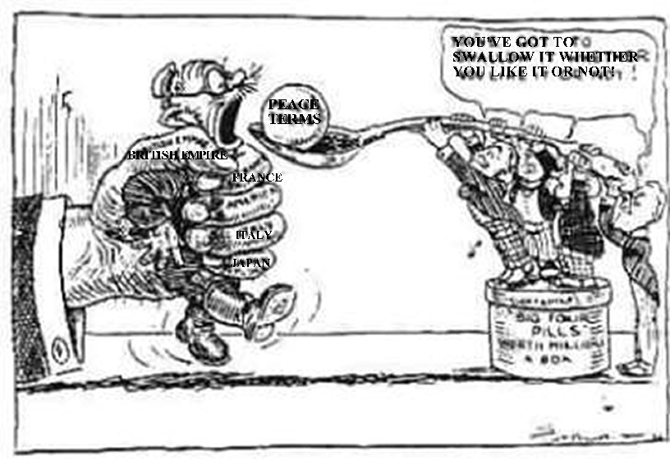
http://www.historyonthenet.com/WW1/versailles.htm
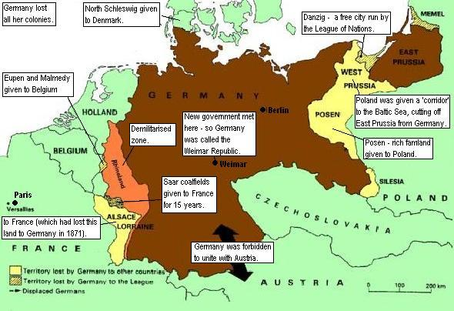http://www.johndclare.net/peace_treaties4.htm

ACTIVITIES:

- Who do you think was responsible for the outbreak of the war? Give arguments for your statements.
- Write the headlines and a short article on the beginning of the war: national patriotism and interests, the Sarajevo assassination…, from the perspective of the Austrian and the perspective of the British or French.
- Do you think the First War World was an imperialist war? Why or why not?
- Read the two songs –you can listen to the tunes as well. What do they have in common? What is the vision they give us about World War I and about wars in general?
- Analyse the cartoon above and explain its meaning.
- According to the map and to the following clauses, What were the territorial consequences of the Versailles Treaty? Which other clauses were harmful for Germany?
- Were the Germans right for feeling humiliated and betrayed because of this Treaty? Why? Should a defeated country be excluded from negotiation and be harshly punished? What should be the obligations from war victors towards defeated countries?
- Analysing every country’s reasons to blame the Treaty. Which one do you think had more reasons to protest? Which one had fewer reasons to protest?
- Write a short essay –maximum one page- stating whether the Versailles Treaty was t a good Treaty or not and its flaws –if any.

